**Assignment 3**

* **Creating Database**

CREATE DATABASE emp_dep_db;

* **Creating Tables**
  1. Employee

CREATE TABLE employee(

emp_id INT PRIMARY KEY,

dept_id INT,

mngr_id INT,

emp_name VARCHAR(30),

salary INT

FOREIGN KEY (dept_id) REFERENCES department(dept_id)

);

* 1. Department

CREATE TABLE department(

dept_id INT PRIMARY KEY,

dept_name VARCHAR(20) NOT NULL

);

* **Queries**

1)

SELECT E.emp_id, E.emp_name, E.salary, D.*

FROM employee E

JOIN department D

ON D.dept_id = E.dept_id

JOIN (SELECT dept_id, MAX(salary) AS salary

FROM employee

GROUP BY dept_id) AS mx

ON mx.dept_id = E.dept_id AND mx.salary = E.salary

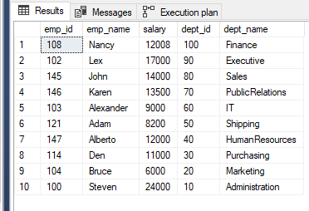

2)

SELECT COUNT(*) AS 'count', D.dept_name

FROM department D

LEFT JOIN employee E

ON D.dept_id = E.dept_id

Group by E.dept_id, D.dept_name

HAVING COUNT(*) < 3

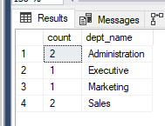

3)

SELECT D.dept_name, COUNT(*) AS 'number of employees'

FROM department D

LEFT JOIN employee E

ON E.dept_id = D.dept_id

GROUP BY D.dept_name;

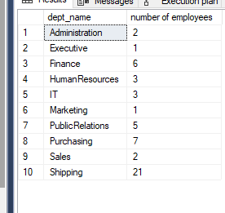

4)

SELECT D.dept_name, SUM(E.salary) AS 'total salary'

FROM department D

LEFT JOIN employee E

ON E.dept_id = D.dept_id

GROUP BY D.dept_name;

